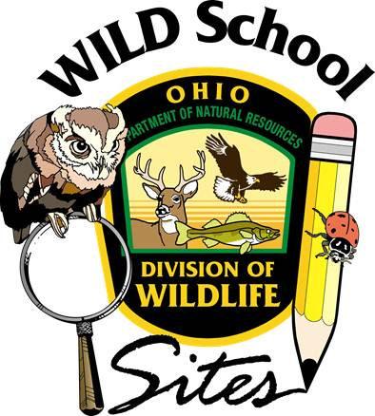
WILD About Research
August 8-9, 2023
9:00am to 4:30pm both days
Granville High School, Granville, Licking County

Day 1
9:00am Introductions, Goals—High School STEM Space
9:15-10:00am | Opening-Jim Reding and Superintendent Jeff Brown, Granville EVSD and Brent Sodegren, USFWS
10:00-11:15am | Mapping it Out | Funding and Collaborating | Committees and Planning
12:00 -1:00pm |  | LUNCH
1:15-2:30pm | Pollinators-Jamey Emmert | Herps-Greg Lipps | Birds and Bird Monitoring-Joseph
2:45--4:00pm | Insects-Jamey Emmert | Trail Cams and other Tech-Greg Lipps | Fish-Lyndsey Manzo
4:15 pm--Please bring an aerial map of your school grounds. Instructors can help you map out potential projects and brainstorm ideas for your site. High School STEM Space
Day 2
9:00am-- What kinds of plans do you have and need help with? We’ll brainstorm a list for further research.- High School STEM Space
9:15-10:00am | Kristen Stanford-The Importance of Research AND Education and it’s impact on our wildlife populations.
10:45-12:00pm |  | Mapping it Out |  | Funding and Collaborating |  | Committees and Planning
10:45-12:00pm | Career Tech and Research-Ryan Curtis |  | Phenology-Lindsay Rist |  | Student Led Projects and How to Manage Them
12:00-1:00pm |  |  | LUNCH
1:15-2:30pm |  |  | The Not-So-Wild Creatures of a Classroom-Jim Reding |  | Habitat Management-Pitfalls and other things to consider
2:45-4:00pm | Panel Discussion-Final opportunities to ask questions from the experts-High School STEM Space

4:15pm--Wrap up, certificates, CEU documents-High School STEM Space

