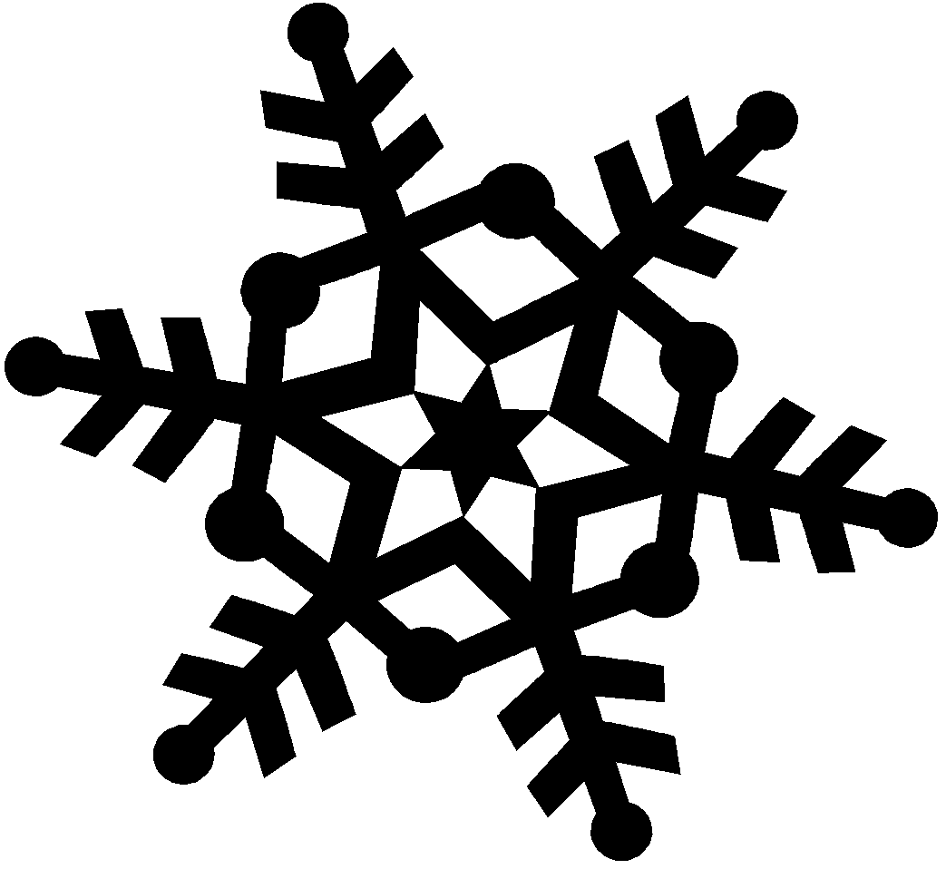
Winter Snow – Creative Ways to Teach STEAM
EECO Winter CONFERENCE January 27th and January 28th, 2023
The conferencewill be held at the fabulous Camp Nuhop, 1077 Hanover Twp. Rd. 2916, Perrysville, OH 44864.

Fees:
Full conference: (Friday-Saturday, 2 meals, snacks, and lodging) : Member $55 and Non-member $90
Saturday Only: (2 meals, snacks, no lodging): Member $40 and Non-member $75
Student: Full Conference: $25 ; Sat Only $10

Schedule and Session Descriptions

Friday- January 27th
6:00 – 7:00pm Conference Registration and Room Check–in Location: Library
7:00 – 9:00pm Welcome/EECO Update and Open Space Location: Dining Hall

EECO Update:
Current events and programs going on with EECO and partnering organizations.

Open Space with Carrie Elvey:
Have a project or program that you really want to share? Or do you have a conundrum that you need some assistance or ideas to make the program happen? We will have an open space opportunity for multiple topics.

Saturday – January 28th
7:30 – 8:00am Morning Hike- Optional
8:00 – 9:00am Registration for Day Participants
8:00 – 8:45am Breakfast
9:00 – 10:00am Concurrent Sessions I
10:10 – 11:10am Concurrent Sessions II
11:30 – 1:00pm Lunch/Afternoon Optional Hike
1:15 – 2:15pm Group Session: Sue Cook, Laura Grimm and Brenda Metcalf
2:30 – 3:30pm Concurrent Sessions III
3:45 – 4:45pm Concurrent Session IV
5:00 pm Evaluations and Resource distribution

Saturday Group Session: Reflecting on the Winter Snow Conference past, present and future
Sue Cook, Laura Grimm and Brenda Metcalf will give a varying accounts of Winter Snow conferences over the years with a remembrance of Herb Broda, the Winter Snow King for 40 years! Where we have been with the Winter Snow Conference and where we want to go. Join us in the discussion with ideas for the future.

Session I Presentations:

Animals in Winter- Brittany Spratt; Edge of Appalachia Nature Preserve
Investigate the different ways animals survive in the winter by utilizing museum specimens and/or live animals! The focus of this engaging session will be on comparing how ectothermic & endothermic animals survive in the winter, but also touch on ecosystems, food chains / food webs, and adaptations. Also, discover local resources for obtaining study skins, furs, and other teaching materials! For Upper Elementary- Library

Jen Dennison- ODNR, Division of Wildlife- Dining Hall THIS IS A DOUBLE SESSION
Part 1- Teaching about climate change presents several challenges for educators. The subject matter is complex and often abstract, it expands across academic subjects, and can be emotionally charged. The Project WILD Climate and Wildlife module was assembled to better equip educators in efforts to increase understanding, critical thinking, and ability to make well-informed decisions regarding their impacts on climate change through the lens of wildlife and their habitats. Participants in this session will get to know the module by exploring a few of the activities, resources for content and materials, and they’ll take home the module to use in their own classes.- Dining Hall

Session II Presentations:

Children’s Books and the Outdoors!- Jenny Adkins; MAD Scientist Associates
Explore the beauty of children’s books and our outdoor world with Jenny Adkins from MAD Scientist Associates. This session walks you through a typical pre-K/elementary program that starts with a story and discussion, followed by an outdoor walk to look for objects and ideas mentioned in the story. This focuses on the “S” in STEM, but is really a holistic educational activity that allows kids to explore their local environs, observe seasonal changes, and gain literacy skills. - Library

Jen Dennison- ODNR, Division of Wildlife- Dining Hall THIS IS A DOUBLE SESSION
Part 2- Teaching about climate change presents several challenges for educators. The subject matter is complex and often abstract, it expands across academic subjects, and can be emotionally charged. The Project WILD Climate and Wildlife module was assembled to better equip educators in efforts to increase understanding, critical thinking, and ability to make well-informed decisions regarding their impacts on climate change through the lens of wildlife and their habitats. Participants in this session will get to know the module by exploring a few of the activities, resources for content and materials, and they’ll take home the module to use in their own classes. - Dining Hall

Session III Presentations:

Ohio’s Wildlife Timeline with Alli Shaw of Columbus & Franklin County Metro Parks
In this hands-on, indoor session, we'll embark on a journey from pre-statehood until present-day to learn about the interesting connection between Ohio history and natural history. This interdisciplinary activity includes science, social studies and language arts elements. We'll also explore success stories, mammal pelts, feathers, and additional resources as part of the session. - Dining Hall

Dragon Quests and Egg Hunts with Karen Pryor of Richland County Park District
Using creative and focused scavenger huts to engage the whole student (body, mind and imagination) in a meaningful nature education activity. For students of all ages. - Library

Session IV Presentations:

Indoor Seed Starting for Outdoor Learning Spaces- Denise Natoli Brooks; Central State University Extension
Get a head start on your outdoor learning spaces by starting your own flowers, grasses, shrubs and trees indoors this winter. Proper planning and applying several STEAM skills can result in beautiful seedlings. Seedling can be planted outdoors onsite or sold as a fundraiser to support your outdoor learning space. Participants will plant and take home a few future seedlings. – Dining Hall

Create your next EE Program using the NAAEE Guidelines for Excellence!- Sheila Cubick- EECO Regional Director for Region 3 An overview of the NAAEE Guidelines for Excellence, how they were developed, and how to use them to create top-notch Nonformal Environmental Education Programs for your organization. Group discussions and activities will illustrate the process in using the guidelines.
- Library

