2023 EECO CONFERENCE
April 14- 16, 2023
SCHEDULE AT A GLANCE

FRIDAY April 14
All Day | Exhibits | Ballroom Hallway
8:00am-7:00pm | Registration | Lobby
Workshops and Field Trips
8:30am-4:30pm | FT1 - Battelle Darby Creek Metro Park - Flora, Fauna and More! | Meet in the Lobby
8:30am-4:30pm | FT2- Ohio Native American Earthworks and Natural History Tour | Meet in the Lobby
9:00 am- Noon | W1- Landscape for Life | Black Oak room
9:00 am- Noon | W2 - Loose Parts and the Environment | Chestnut room
Noon - 1pm | Lunch
1pm-4:30pm | FT3 - Pickaway County Park District - Old and New | Meet in the Lobby
1pm-4pm | W3 - Climate Water and Resilience- Project WET’s Climate | Black Oak room
1pm-4pm | W4 - Using Phenology to Teach Students About Climate Change | Chestnut room
5pm | Silent Auction open for bidding | Parlour A & B
5pm-6pm | Networking Time
5pm-6pm | Hospitality Room open | Room 101
6pm–7pm | Welcome Dinner & Keynote: Marci Lininger | Grand Ballroom
7pm-8:30pm | Open Space | Grand Ballroom
9pm-10pm | Night Hike (Weather Permitting) | Meet in the Lobby
9pm-11pm | Hospitality Room open | Room 101
SATURDAY April 15
All Day | Exhibits
All Day | Silent Auction (ends at 6 pm) | Parlour A & B
7am | Registration | Lobby
7am-8am | Bird Hike (weather permitting) | Meet in the Lobby
8am-9am | Breakfast & Regional Meetings | Grand Ballroom
9am-9:15am | Welcome | Grand Ballroom
9:30am-10:30am | Concurrent Sessions 1
A1 | Here Today, Gone Tomorrow | Scarlet Oak room
A2 | Making Old Woman Creek NERR a More Accessible Place | Chestnut room
A3 | Loose Parts and the Environment | Black Oak room
A4 | Believe in Ohio- A STEM & Entrepreneur Program for Ohio Youth | Buckeye room
Kids Workshop 1 | Spirit Animal Connections | Meet at Registration
10:45 am-11:45am | Concurrent Sessions 2
B1 | Population & Climate Change: Activities for any EE Setting | Scarlet Oak room
B2 | An Overnight in the Woods | Chestnut room
B3 | Building a Wigwam | Black Oak room
B4 | Career Chats: We've Got A Hit on Our Hands! | Buckeye room
Kids Workshop 2 | Wetland Hike | Meet at Registration
12pm-2pm | Lunch, Annual Meeting, & Keynote Speaker: Marijke Hecht | Ballroom
SATURDAY April 15
2:15pm-3:15pm | Concurrent Sessions 3
C1 | Into the Wild: Urban High School Students Experience Midwestern Geology | Scarlet Oak room
C2 | Integrating Project WET, Wetlands & H2Ohio into 7th grade | Chestnut room
C3 | Kids Town: Let Your Students Lead & Learn | Black Oak room
C4 | Making it Fun! Collaboration and Education Through Fishing | Buckeye room
Kids Workshop 3 | Invertebrate Microscopy | Meet at Registration
3:15pm-3:30pm | Afternoon Break | Ballroom Hallway
3:30pm-4:30pm | Concurrent Sessions 4
D1 | Invisible Disabilities: How SPD, ACES & PTSD Impact Activities | Scarlet Oak room
D2 | Ice Age Mammals of Ohio | Chestnut room
D3 | Building Lasting Connections & Knowledge with Native Reptiles | Black Oak room
D4 | Fears to Cheers: Employing Fear for Conservation Values | Buckeye room
Kids Workshop 4 | Nature Poetry & Art | Meet at Registration
4:30pm-6pm | Networking & Silent Auction | Parlour A & B
4:30pm-6pm | EE Certification Alumni Meet-Up | Parlour Foyer
5pm | EE Certification Poster Session | Parlour Foyer
5pm | Cash Bar opens | Parlour Foyer
6pm | Silent Auction closes
6pm | Awards Banquet, Live Auction | Grand Ballroom
9pm | Campfire (Weather Permitting) | Fire Pit
9pm | Hospitality Room open | Room 101
SUNDAY, April 16
7am-8am | Bird Hike (weather permitting) | Meet in the Lobby
7:30am-9:30am | Evaluation Collection | Registration Table
8am-9am | Breakfast | Grand Ballroom
9am-noon | Deer’s Eye View of Deer Creek tour | Meet in the Lobby
Deer Creek Lodge Layout
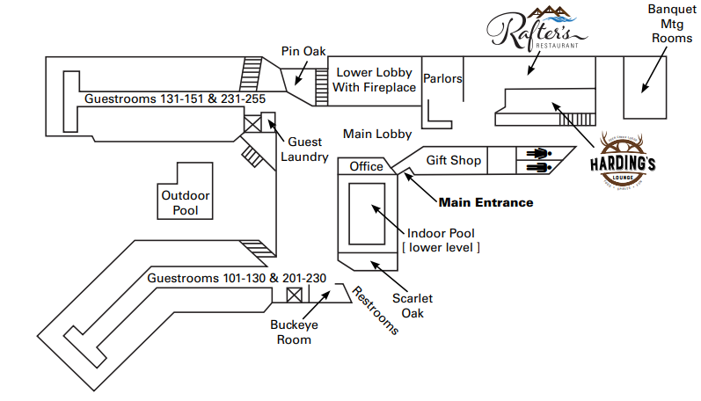

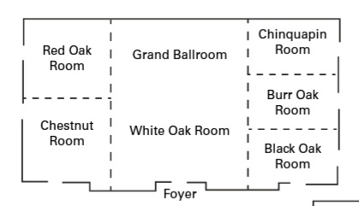
Ballroom/Banquet Mtg. Rooms

