Need College Credit, CEU’s or just want to have some fun? Summer EECO Tour: Climate Art Walk
Downtown Columbus, Short North Arts District
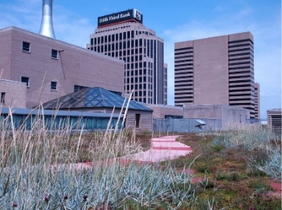
Optional pre-tour of Lazarus Building green roof for first 20 to register
The Greater Columbus Arts Council (GCAC) presents Art Spot, a collection of 13 window installations designed by Columbus-area artists, on display around downtown Columbus and the Short North Arts District from mid-December through June 2023. As part of GCAC’s ongoing mission to connect art with the people and places of Columbus, Art Spot is designed to highlight the city’s artists while promoting engagement between residents, visitors, and downtown businesses.
A LEED Gold rating means that renovation of the century-old Lazarus department store achieved a high level of environmental sustainability in site development, water savings, energy efficiency, materials selection, and indoor environmental quality. A “living” roof reduces summer heat buildup and slows water runoff. This pre-tour is free but due to space considerations will be limited to 20 people.
What we will do: Both the pre-tour and the Climate Conversations Art Walk will start at the Lazarus Galleria where exhibits showcase the LEED renovation. The art walk around downtown Columbus is approximately 2 miles to visit 9 art spots while completing a climate change quiz. Evening ends with a snack break at one of the downtown spots, like Condado Tacos or The Goat RiverSouth on High Street.
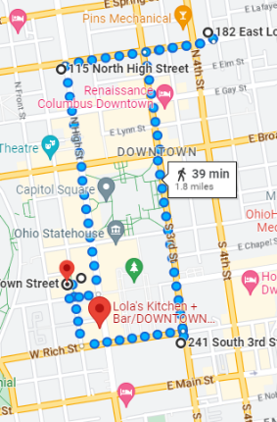
When: Friday, June 16, 2023, 4:55 – 5:45 pm for Green Roof tour attendees
6:00 – 8:00 p.m. for walking tour of downtown climate art installations

Cost: $25.00 (Your food & drinks will be extra)
Schedule:
4:55 – 5:45 p.m. For first 20 people to register, guided tour of Lazarus building living roof. Meet in the Galleria (141 South High Street, Columbus, OH 43215) and depart at 5 p.m. sharp!
6:00 – 8:00 p.m. The Climate Art Walking Tour will meet in the Lazarus Galleria and follow the map of the downtown art spots. While walking around complete the climate change quiz. Dress for the weather with comfortable walking shoes.
8:00 – 9:00 p.m. Snack break. Meet at a group agreed upon watering hole and compare answers to the climate change quiz.
Register online: Environmental Education Council of Ohio - Summer EECO Tour (eeco-online.org)
Questions? Contact Frances.Boyens@LM.DOE.GOV
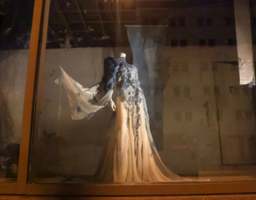
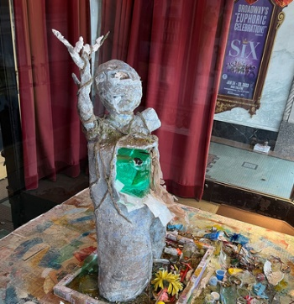
EECO offers contact hour certificates to use for CEUs with professional development committees. We are seeking college credit. To be eligible for credit hours you will need to attend at least 3 EECO Tours. We will be offering at least 4 tours, one per season.
Photo Credits: www.columbusmakesart.com

