Anti-Racist Resource Guide
https://tinyurl.com/antiracistresourceguide
Created by Victoria Alexander, MEd.: Twitter | Instagram | Facebook | Website

This document was created to be used as a resource for anyone looking to broaden their understanding of anti-racism and get involved to combat racism, specifically as it relates to anti-Blackness and police violence. Within this guide, please find a variety of resources to explore practical ways to understand, explain, and solve seemingly intractable problems of racial inequity, white supremacy, police violence, and injustice.

Please share widely to your friends, family, students, and colleagues.
Thank you for your allyship.

Contents:
- Structural Racism vs Individual Racism
- Understanding Implicit Bias
- Steps to Becoming Anti-Racist
- Organizations to Connect With
- How to Find Protests and Rallies
- Where to Donate, Sign Petitions, Contact Reps.
- Justice For Breonna Taylor/Birthday For Breonna
- Prepare for Election Day, This November

Having Conversations about Racism and Bias
- Articles to Read
- Books to Read
- Videos to Watch
- TV Shows and Movies to Watch
- Podcasts to Listen to
- Black Businesses to Support
- Children’s Anti-Racist Resources

Structural Racism vs Individual Racism
Racism describes a system of power and oppression/advantage and disadvantage based on race. Structural racism is a system, or series of systems, in which institutional practices, laws, policies, social- cultural standards, and socio-political decisions establish and reinforce norms that perpetuate racial group inequities. Within the context of the United State of America, and other nations, structural racism takes the form of white supremacy; the preferential treatment, privilege, power, access, networks, and access to opportunities available to white people, which often designate communities of color to chronic adverse outcomes.
Individual racism refers to a person’s racist assumptions, beliefs, or behaviors. Individual racism stems from conscious and unconscious bias and is reinforced by structural racism. Please visit the list of books, videos, movies, and TV shows within this guide to learn more about how racism functions and affects all of our day-to-day lives.

Understanding Implicit Bias
Implicit bias refers to the attitudes or stereotypes that affect our understanding, actions, and decisions in an unconscious manner. These are mental shortcuts that help us more easily make sense of our incredibly complex world. These biases, which encompass both favorable and unfavorable assessments, are activated involuntarily and without an individual’s awareness or intentional control. These associations develop over the course of a lifetime beginning at a very early age through exposure to direct and indirect messages.
We all have implicit biases, no matter our identities and regardless of how educated we are on the topic. These biases manifest themselves in ways that have impacts we may not desire.
Have you ever had a knee-jerk reaction or thought related to a person or situation, and then thought to yourself something like “That wasn’t cool of me” or “No, that is not the right thing to think;” that is your implicit bias and then your active consciousness reconsidering that bias.
It is difficult for many of us to talk about implicit or explicit bias; we are often brought up to believe that we live in a “just world,” that we treat people how they should be treated and as a result people get what they deserve. Bias directly contradicts that world view and our self or group concept.
Though we can learn and internalize these messages and biases very early in our lives, implicit biases are malleable and the associations we form can be unlearned. You engaging with this resource guide, in a meaningful way, lets me know that you are interested in learning how to shift your implicit biases toward an anti-racist lens. To learn more about how bias is learned, internalized, unlearned, and changed, please visit the list of books, articles, tv shows, and movies included in this guide.

Steps to Becoming Anti-Racist
Originally published by WhereChangeStarted.com

- Awareness
This is your initial awakening to the racial injustices around you. You are not only finally able to see that they exist, but that you play a crucial role in stoping the cycle by becoming anti-racist.

Being aware of racial injustices or understanding that you have privilege won’t make you antiracist, however. You have to keep going through the remaining stages.

Brace yourself though. This awakening is not a one time event. It will happen once, on a broad level regarding race and white supremacy, but will continue to happen on issue specific levels as you dive deeper into the work and create space for more and more varied lived experiences in your understanding of these systems.

- Education
This is where you become an intentional student in this work. If you are engaging with this resource guide, it is likely the stage you are in right now. From webinars, lectures, and workshops, to blog posts, books, and documentaries, you study the complexities of racism and the many ways it manifests within our society.

The point of educating yourself on race and white supremacy isn't for you to be able to articulate these complex topics in intellectual debates about inequality. Its about you being able to develop the eye for identifying white supremacy in its many forms (in others and in yourself) without being hand-held to do so.
This stage of the process is crucial to the remaining stages of the work because you need a solid foundational understanding of white supremacy and race in order to begin the work of dismantling your own thoughts, beliefs, and practices that perpetuate and uphold it.

Do this with intention. Don’t just accumulate resources to skip, without diving deep into them.

- Self Interrogation
This is the stage where the real self work begins. This is where you disarm yourself of the racist tools of defence that you’ve used to bypass the work of anti-racism and harm people of color in your efforts. This is where you begin to replace them with tools of accountability to stop racist behaviors.

Self interrogation is a skill and a process. Being effective and efficient at this stage takes time and practice.

While it will start out as the part of this work that source the most discomfort within you, you will eventually get to a place where you’re operating out of a growth mindset and embrace the many ways to identify how you can better be living up to the person you want to be in this fight for human equality.

- Community Action
Only after the appropriate effort in the self-interrogation stage of becoming anti-racist can you be trusted to do anti-racism work in a way that honors communities of color. Attempting to do this part of the work without accomplishing the first three stages is how you end up harming communities of color with white saviorism, performative allyship, and more (which is just your garden variety of white supremacy to begin with).

In stage four, you incorporate what you’ve learned during your ongoing process of becoming anti-racist into your everyday life. You leverage your positions of leadership and influence - no matter how big or small - to encourage others to do their own work in anti-racism. You elevate the intellectual contributions and scholarship of people of color educators and thought leaders in the process.

This stage of the work will not be void of mistakes, but the way those are handled and the number of times they are repeated thereafter (as least as possible), is what will make the difference here. Because leading by example in your failures is but one of the many ways for you to do this work authentically.

Organizations to Connect With & Stay Informed
The Antiracist Research & Policy Center: Website | Twitter | Facebook | Instagram
Audre Lorde Project: Website | Twitter | Instagram | Facebook
Black Lives Matter: Website | Twitter | Instagram | Facebook
Black Lives Matter has various local chapters. Find yours here!
Black Women’s Blueprint: Website | Twitter | Instagram | Facebook
Color Of Change: Website | Twitter | Instagram | Facebook
Colorlines: Website | Twitter | Instagram | Facebook
The Conscious Kid: Website | Twitter | Instagram | Facebook
Equal Justice Initiative (EJI): Website | Twitter | Instagram | Facebook
Families Belong Together: Website | Twitter | Instagram | Facebook
Higher Heights Leadership Fund: Website | Twitter | Instagram | Facebook
Leadership Conference on Civil & Human Rights: Website | Twitter | IG | FB | Youtube
The Movement for Black Lives: Website | Twitter | Instagram | Facebook | Youtube
NAACP: Website | Twitter | Instagram | Facebook
NAACP Legal Defense Fund: Website | Twitter | Instagram | Facebook
National Urban League: Website | Twitter | Instagram | Facebook | Youtube
Showing Up for Racial Justice (SURJ): Website | Twitter | Instagram | Facebook
SURJ has various local chapters. Find yours here!
Southern Poverty Law Center: Website | Twitter | Instagram | Facebook
United Negro College Fund: Website | Twitter | Instagram | Facebook
Woke Vote: Website | Twitter | Facebook | Instagram

How to Find Protests and Rallies
- Search in the Events section of Facebook for protests in your area
  - Use keywords like rally, march, protest, Black Lives Matter
- Sign up for updates and newsletters from the organizations in the section above, specifically the local chapters of national organizations
- Sign up for Google Alerts using keywords like rally, march, protest, resist, Black Lives Matter, and your town or city
- Check your local “activism calendar” on Google
- Search for relevant keywords on Twitter
- Keep up with Rally List
- Stay informed with your local Black Lives Matter chapters
- Know Your Rights as a Protester, ACLU

Where to Donate, Sign Petitions, Contact Reps:

The Bail Project
We believe that paying bail for someone in need is an act of resistance against a system that criminalizes race and poverty and an act of solidarity with local communities and movements for decarceration. Over the next five years, The Bail Project will open dozens of sites in high-need jurisdictions with the goal of paying bail for tens of thousands of low-income Americans, all while collecting stories and data that prove money bail is not necessary to ensure people return to court.

Baltimore Action Legal Team
BALT is committed to building the power of the local Movement for Black Lives. We take our direction from community-organizing groups who are on the ground, and we respect the leadership of local activists. BALT is committed to anti-racist practices and to black leadership. BALT is dedicated to politically-conscious lawyering and to using creative, collective solutions to support the Movement for Black Lives in Baltimore.

Black Lives Matter Foundation
#BlackLivesMatter was founded in 2013 in response to the acquittal of Trayvon Martin’s murderer. Black Lives Matter Foundation, Inc is a global organization in the US, UK, and Canada, whose mission is to eradicate white supremacy and build local power to intervene in violence inflicted on Black communities by the state and vigilantes.

Black Visions Collective - MN
Since 2017, Black Visions Collective, has been putting into practice the lessons learned from organizations before us in order to shape a political home for Black people across Minnesota. We aim to center our work in healing and transformative justice principles, intentionally develop our organizations core “DNA” to ensure sustainability, and develop Minnesota’s emerging Black leadership to lead powerful campaigns.

Fair Fight
Founded by Stacey Abrams, promotes fair elections by bringing voter discrimination to light with education programs and election reform advocacy.

George Floyd Memorial Fund
This fund is established to cover funeral and burial expenses, mental and grief counseling, lodging and travel for all court proceedings, and to assist our family in the days to come as we continue to seek justice for George. A portion of these funds will also go to the Estate of George Floyd for the benefit and care of his children and their educational fund.

Higher Heights Leadership Fund
Higher Heights Leadership Fund's work is to elevate Black women's voices to shape and advance progressive policies and to provide opportunities for these women to build their leadership skills, through training programs, civic engagement, and networking opportunities.

Justice for Breonna Taylor
Breonna Taylor was an award-winning EMT and model citizen. She loved her family and community. She worked at two hospitals as an essential worker during the pandemic. One month ago, a division of the Louisville Police Department performed an illegal, unannounced drug raid on her home. Not a single officer announced themselves before ramming down her door and firing 22 shots, shooting Breonna 8 times, killing her. Not only were the police at the WRONG HOUSE, but the man they were looking for had already been arrested earlier that day.

Louisville Community Bail Fund
The Louisville Community Bail Fund exists to not only bail out folks, but provide post-release support to get them from jail, fed, and to a situation of safety. LCBF also maintains a focus on preventative measures for those targeted by law enforcement and threatened with incarceration.

Massachusetts Bail Fund
The Massachusetts Bail Fund pays up to $2,000 bail so that low-income people can stay free while they work towards resolving their case, allowing individuals, families, and communities to stay productive, together, and stable.

Minnesota Freedom Fund
The Freedom Fund remains committed to #FreeThemAll. We say again: it is wrong to cage people, to jail those who are not a risk to themselves or their communities, to imprison those who cannot afford to pay the ransom of bail, and to hold in detention those whose “crime” is being born in a different part of the world.

NAACP Legal Defense Fund
While we are living in a moment unlike any we have seen before, LDF will continue to work to protect the most vulnerable in our society. During this public health emergency, the fight to defend our civil and human rights has never been more critical. Donate today to help us win landmark legal battles, protect voters across the nation, and advance the cause of racial justice, equality, and an inclusive society.

National Urban League
To help African-Americans and others in underserved communities achieve their highest true social parity, economic self- reliance, power, and civil rights. The League promotes economic empowerment through education and job training, housing and community development, workforce development, entrepreneurship, health, and quality of life.

People’s City Council Freedom Fund
Los Angeles-based fund helping to pay for legal support, bail, fines, and court fees for arrested protesters in the city, as well as medical bills and transportation for injured protesters, supplies for field medics, and direct support to L.A.’s Black Lives Matter chapter.

Reclaim the Block
Reclaim the Block began in 2018 and organizes Minneapolis community and city council members to move money from the police department into other areas of the city’s budget that truly promote community health and safety. We believe health, safety and resiliency exist without police of any kind. We organize around policies that strengthen community-led safety initiatives and reduce reliance on police departments.
The Resignation of City Councilman Bob Kellar
Bob Kellar, a former officer of the LAPD and current city councilmen, in his own words is “a proud racist.”Kellar has been an elected member of the Santa Clarita city council since 2000, maintaining a gripping white supremacist stronghold on our town.

Run With Maud
He was out for a jog when he was chased down, shot, and killed by two white supremacists. We must demand the justice he deserves. Call 770.800.0689 to demand justice for Ahmaud right away.

Southern Poverty Law Center
The SPLC is dedicated to fighting hate and bigotry and to seeking justice for the most vulnerable members of our society. Using litigation, education, and other forms of advocacy, the SPLC works toward the day when the ideals of equal justice and equal opportunity will be a reality.

Woke Vote
We are on a mission to rid us of mass incarceration, voter suppression, and urban gun violence. Woke Vote is here to challenge politicians that think about neglecting and exploiting our communities. By supporting progressive, righteous leaders and holding them accountable, we are reclaiming power and promoting justice for all.

United Negro College Fund
UNCF envisions a nation where all Americans have equal access to a college education that prepares them for rich intellectual lives, competitive and fulfilling careers, engaged citizenship and service to our nation.

Justice For Breonna Taylor/Birthday For Breonna
Breonna Taylor should have turned 27 years old on June 5th, 2020. Instead, on March 13th, 2020, the Louisville Police Department performed an illegal, unannounced drug raid on her home. The police officers were at the wrong address, dressed in plain-clothes, AND were searching for someone who had been taken into police custody earlier that day. Breonna’s boyfriend, a registered gun-owner, fired at this group of armed, plain clothed, unannounced intruders. The police officers fired back with dozens of shots, hitting Breonna eight times as she slept, taking her life.
More than two months later, the police officers involved have not been arrested or charged. Here are some resources you can use right now to demand justice for Breonna”
1) Sign the Justice For Breonna Petition at Change.Org
2) Here is what the "Justice for Breonna Taylor" petition calls for:
a. Charges must be filed immediately. Arrests of the officers involved, specifically John Mattingly, Brett Hankison, Myles Cosgrove, and any other officer involved in the death and coverup of the death of Breonna Taylor must be made NOW. There have been no charges thus far (it has been a month). This is unacceptable.
b. Her family must be paid in damages for wrongful death and the negligence of the LMPD.
c. Kentucky Governor Andy Beshear must speak up on behalf of Breonna, and Governor Beshear or Attorney General Daniel Cameron must appoint a special prosecutor to investigate the Louisville Police Department immediately. An in-house investigation is unacceptable.
d. The "no-knock" warrant that police had used in Breonna's murder completely violates the constitutional rights to reasonable search and seizure. By law, police must be legally obligated to announce themselves before breaking and entering into a home privately owned by American civilians. Legislation to federally ban no-knock warrants must be passed in Congress and signed by the President; what happened to Breonna was a complete violation of her constitutional rights, and threatens the rights of all American citizens. Senator Rand Paul of Kentucky has voiced similar concerns. A special session must be intervened by Congress to discuss the constitutionality of no-knock warrants immediately.

3) Send birthday cards to the Louisville mayor and the Kentucky Attorney General
a. Cards should be addressed as follows:
Office of the Attorney General
700 Capital Avenue, Suite 118
Frankfort, Kentucky 40601-3449

Mayor Greg Fischer
527 W Jefferson Street #600
Louisville KY 40202
4) Email the Kentucky Attorney General and Louisville mayor at attorney.general@ag.ky.gov and greg.fischer@louisvilleky.gov.
a. If you aren't sure of exactly what to say, please find a pre-scripted email here.
5) Donate to Breonna’s Family
6) Donate to the Louisville Bail Fund
a. The Louisville Community Bail Fund serves protestors on the ground in Louisville as they fight for justice for Breonna Taylor and to bring about an end to police brutality and systemic racism
7) Text ENOUGH to 55156.
8) Flood social media with #JusticeForBreonna #BirthdayForBreonna and #SayHerName to bring awareness to the fight for Breonna and all women who have experienced police violence
To better understand the nuance of police violence against Black women, please watch: The Urgency of Intersectionality, by Kimberle Crenshaw

Prepare for Election Day, This November
This November is the next Presidential election. The future of the nation is in our hands. Here’s what we can do about it:

- Think you’re registered to vote? Double check here
- Register to vote here (it takes less than 2 minutes)
- Don’t live in the state you're registered in? Check your state’s absentee rules here
- Request your vote by mail ballot here
- Not super sure how Presidential elections work? Learn more here
- Want to help turn swing states blue? Sign up for Crooked Media’s Adopt A State
- Find ways to volunteer in democratic campaigns here

Other resources to prepare for Election Day, November 2020
Crooked Media - Vote Save America
Swing Left
Make Calls to Swing States
Donate to National Impact Fund
Write Letters for Super State Voters
Text VOLUNTEER to 43367 to stay involved with volunteer opportunities near you

Having Conversations about Racism and Bias

Reading books and watching documentaries on anti-racism is one thing but how are you bringing that energy into your day-to-day lives and interpersonal relationships? If you’re going to be on this journey toward being anti-racist, you must commit to combating racism and bias when you see it and hear it.

Common questions include things like “what do I say when someone is racist but doesn’t mean it?” “Should I speak up when someone offends my identity at work?” “How can I talk to my parents about their racist language?” “How do I check my Uncle Bob when he’s actin’ a fool at the dinner table?” Like doing anything new, IT'S SCARY! But that’s okay! I’ve put together some quick references for you to read and practice so you can start changing the minds and hearts of people in your life. Remember, “It takes a great deal of bravery to stand up to your enemies, but a great deal more to stand up to your friends.” - Albus Dumbledore.

Responding to Microaggressions and Bias, Dr. Diane J. Goodman

Responding to Implicit Racism, Victoria Alexander

Are Your Kids Too Young To Talk About Race? The Conscious Kid

Tool: Recognizing Microaggressions and the Messages They Send, UCSC, adapted from Sue, Derald Wing
Racial Microaggressions and African American and Hispanic Students in Urban Schools: A Call for Culturally Affirming Education, Allen, Ayana; Scott, Lakia M.; Lewis, Chance W.

The Cycle of Socialization, Adams, M., Bell, L. A., Griffin, P. (1997) Teaching for Diversity and Social Justice
Eight Lessons for Talking About Race, Racism, and Racial Justice, The Opportunity Agenda

Articles to Read

The 1619 Project. Nikole Hannah Jones, The New York Times.

Anti-Racist Checklist for Whites. Robin DiAngelo, 2016.

A Critique of "Our Constitution Is Color-Blind.” Neil Gotanda, 1991.

The Case for Reparations. Ta-Nehisi Coates
Civil Rights Protests Have Never Been Popular, Ta-Nehisi Coates, 2017
Demarginalizing the Intersection of Race and Sex: A Black Feminist Critique of Antidiscrimination Doctrine, Feminist Theory and Antiracist Politics. Kimberle Crenshaw, 1989.

Harvard’s Implicit Bias Test

Killing Us Softly: Navigating State and State-Sanctioned Violence Against Black Men’s Humanity. Charles H.F. Davis III, Keon A. McGuire

Learning from the Outsider Within: The Sociological Significance of Black Feminist Thought. Patricia Hill Collins, 1986.

On Trans Dissemblance: Or, Why Trans Studies Needs Black Feminism. Varun Chaudhry, 2020

Racism, whiteness, and burnout in antiracism movements: How white racial justice activists elevate burnout in racial justice activists of color in the United States, Paul Gorski

Race and Essentialism in Feminist Legal Theory. Angela P. Harris, 1990.

Race without Racism: How Higher Education Researchers Minimize Racist Institutional Norms. Shaun Harper, 2012.

Racism Defined. Dismantling Racism.

Spirit-Murdering the Messenger: The Discourse of Fingerpointing as the Law's Response to Racism. Patricia Williams, 1987.

The Subtle Linguistics of White Supremacy. Yawo Brown, 2015.

Welcome To The Anti-Racism Movement — Here’s What You’ve Missed. Ijeoma Oluo, 2017.

White Fragility and the Rules of Engagement. Robin Diangelo, 2015.

White Privilege: Unpacking the Invisible Knapsack. Peggy McIntosh, 1989.

Whiteness as Property. Cheryl Harris, 1993.

Who’s Afraid of Critical Race Theory?, Derrick A. Bell, 1995.

Who Gets To Be Afraid in America? Ibram X. Kendi

The Year I Gave Up White Comfort: An Ode to my White “Friends” on Being Better to Black Womxn. Rachel Ricketts, 2019.

Books to Read
**Before purchasing any books, please check out this list of Black owned bookstores! Many of them will ship your new literary treasures to you right now!
*This reading list is quite long. We have broken the list out by type, below.

The New Jim Crow: Mass Incarceration in the Age of Colorblindness.. Michelle Alexander.

Being White, Being Good: White Complicity, White Moral Responsibility, and Social Justice Pedagogy. Barbara Applebaum.

I Know Why The Caged Birds Sing. Maya Angelou

The Fire Next Time. James Baldwin.

Giovanni’s Room. James Baldwin.

Racism Without Racists: Color-Blind Racism and the Persistence of Racial Inequality in the United States. Eduardo Bonilla-Silva

Unapologetic: A Black, Queen, and Feminist Mandae for Radical Movements. Charlene A. Carruthers.

Queenie. Candace Carty-Williams.

Other Side of Paradise. Staceyann Chin.

Between the World and Me. Ta-Nehisi Coates

The Water Dancer. Ta-Nehisi Coates

Eloquent Rage: A Black Feminist Discovers Her Superpower. Brittney Cooper.

Women, Race, & Class. Angela Y. Davis

Evicted: Poverty and Profit in the American City. Matthew Desmond

White Fragility: Why Its So Hard for White People to Talk About Race. Robin DiAngelo

The Souls of Black Folk. W.E.B. Du Bois

An Indigenous Peoples' History of the United States. Roxanne Dunbar-Ortiz

For White Folks Who Teach In The Hood… And the Rest of Y’all Too: Reality Pedagogy and Urban Education. Christopher Emdin

Bad Feminist. Roxane Gay

Homegoing. Yaa Gyasi.

Sister Citizen: Shame, Stereotypes, and Black Women in America. Melissa Harris-Perry.

Black Feminist Thought: Knowledge, Consciousness, and the Politics of Empowerment. Patricia Hill Collins.

Ain’t I A Woman: Black Women and Feminism. Bell Hooks.

Killing Rage: Ending Racism. Bell Hooks.

Subtle Acts of Exclusion: How to Understand, Identify, and Stop Microaggressions. Tiffany Jana, Michael Baran.

No Tea, No Shade. New Writings in Black Queer Studies. E. Patrick Johnson.

When Affirmative Action Was White: An Untold History of Racial Inequality in 20th Century America. Ira Katznelson

Stamped from the Beginning. Ibram X Kendi.

How to be an Anti-Racist. Ibram X Kendi.

Nobody: Casualties of America’s War on the Vulnerable, From Furgeson to Flint and Beyond. Marc Lamont Hill

March. (Graphic Novel) John Lewis, Andrew Aydin, Nate Powell

Lies My Teacher Told Me: Everything Your American History Teacher Got Wrong. James Loewen.

Sister Outsider. Audre Lorde.

Zami: A New Spelling of My Name, A Biomythography. Audre Lorde.

The Autobiography of Malcolm X

The Summer We Got Free. Mia Mckenzie.

Dying of Whiteness: How The Politics of Racial Resentment is Killing America’s Heartland. Jonathan Metzel.

Coming of Age in Mississippi. Anne Moody

No Ashes in the Fire: Coming of Age Black & Free in America. Darnell L. Moore.

Student Activism, Politics, and Campus Climate in Higher Education. Demetri L. Morgan, Charles H.F. Davis III

Beloved. Toni Morrison.

The Bluest Eye. Toni Morrison

The Condemnation of Blackness: Race, Crime, and the Making of Modern Urban America. Khalil Gilbran Muhammad

Their Eyes Were Watching God. Zora Neale Hurston.

Half of a Yellow Sun. Chimamanda Ngozi Adichie.

Born a Crime: Stories From A South African Childhood. Trevor Noah.

Becoming. Michelle Obama.

So You Want To Talk About Race. Ijeoma Oluo

Since I Laid my Burden Down. Brontez Purnell.

Blackballed: The Black and White Politics of Race on America's Campuses. Lawrence Ross.

The Color of Law. Richard Rothstein.

Me and White Supremacy. Layla F. Saad

Assata, an Autobiography. Assata Shakur.

Just Mercy. Bryan Stevenson

A Different Mirror: A History of Multicultural America. Ronald Takaki.

Why Are All the Black Kids Sitting Together In the Cafeteria? Beverly Daniel Tatum.

How We Get Free: Black Feminism and the Combahee River Collective. Keeanga-Yamahtta Taylor

Real Life. Brandon Taylor.

The Hate You Give. Angie Thomas.

In Search of Our Mothers Gardens. Alice Walker.

The Burning House: Jim Crow and the Making of Modern America. Anders Walker.

Medical Apartheid: The Dark History of Medical Experimentation on Black Americans from Colonial Times to the Present. Harriet A. Washington

The Warmth of Other Suns. Isabel Wilkerson

Native Son. Richard Wright.

A People’s History of the United States. Howard Zinn.

Anti-Racist Reading List by Type: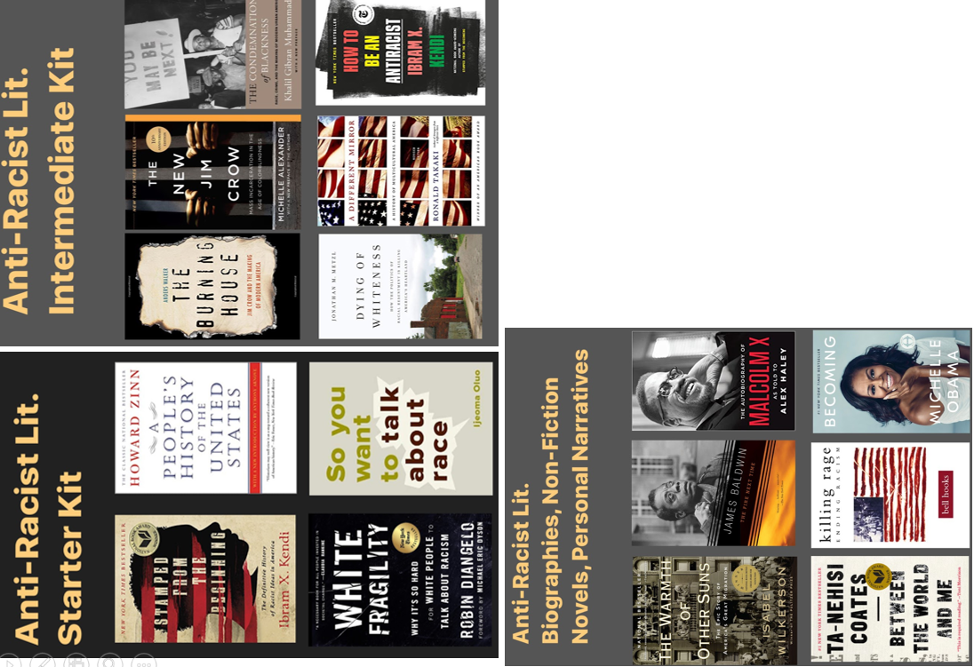
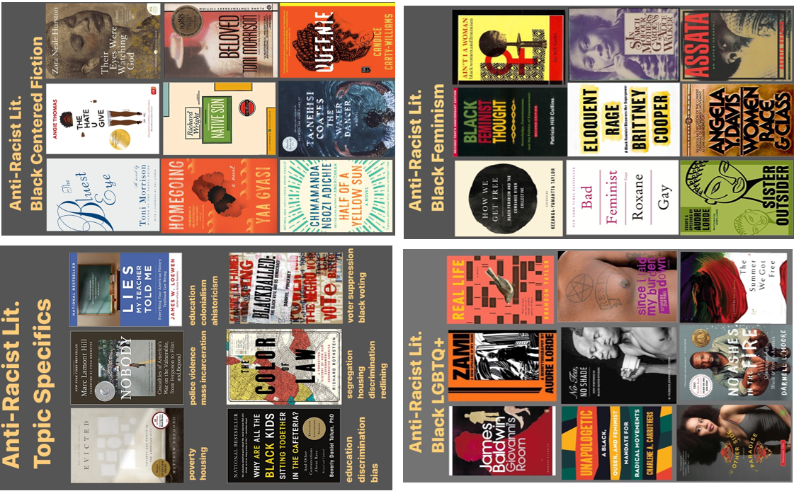

Videos to Watch

The Urgency of Intersectionality, Kimberle Crenshaw

Danger of Silence, Clint Smith III

Ibram X Kendi on the Solution for America’s “Metastatic” Racism, Ibram X. Kendi

Black Bruins, Sy Stokes

Should White People Rap the N-Word?, Ta-Nehisi Coates

Why White People Shouldn’t Say The N-Word Using An Analogy of Wounds, Summer Charles

How To Deconstruct Racism, One Headline At A Time, Baratunde Thurston

“Cuz He’s Black” Spoken Word, Javon Johnson

Three Myths About Racism, Candis Watts Smith

Let’s Get To The Root of Racial Injustice, Megan Ming Francis

What Beyonce Taught Me About Racism, Brittany Baron

“How the Hood Loves You Back” Steven Willis

Being Black by Jane Elliot

How Studying Privilege Systems Can Strengthen Compassion, Peggy McIntosh

The Power of Privilege, Tiffany Jana

TV Shows and Movies to Watch
The 13th (Documentary) — Netflix
American Son (Movie) — Netflix
The Black Panthers: Vanguard of the Revolution (Documentary) — Rent
Dear White People (TV Show & Movie) — Netflix & Rent
The Death and Life of Marsha P. Johnson (Documentary) — Netflix
Do The Right Thing (Movie) — Rent
Fruitvale Station (Movie) — Rent
The Hate U Give (Movie) — Hulu
I Am Not Your Negro (Documentary) — Rent
If Beale Street Could Talk (Movie) — Hulu
Just Mercy (Movie) — Rent (free for the month of June!)
The Kalief Browder Story (Documentary) — Netflix
Loving (Movie) — Hulu
Moonlight — Netflix
Mudbound (Movie) — Netflix
The Murder of Fred Hampton (Documentary) — Rent
Reconstruction: America After the Civil War (TV Series) — PBS
Rest In Power: The Trayvon Martin Story — Rent
Selma (Movie) — Rent
Teach Us All (Documentary) — Netflix
When They See Us (Television Series) — Netflix
Whose Streets? (Documentary on Ferguson Uprising) — Rent

Podcasts to Listen To
1619 (New York Times)
About Race
Afropunk Solution Sessions
Code Switch (NPR)
Come Through With Rebecca Carroll
Intersectionality Matters! hosted by Kimberlé Crenshaw
Momentum: A Race Forward Podcast
The Nod
Pod For The Cause (from The Leadership Conference on Civil & Human Rights)
Pod Save the People (Crooked Media)
Putting Racism on the Table
Race Traitor
Seeing White
Speaking of Racism
There Goes the Neighborhood
The United State of Anxiety
The Wilderness (Crooked Media)

Black Businesses to Support
Brands and buyers have the power to better distribute wealth in America and effect long-term change with your individual buying power. Please reference the following articles to learn more about supporting Black owned businesses in your area.
Black Owned Bookstores in the US
The “Support Black Owned” App
Marie Claire, 27 Black-Owned Brands to Support Today and Every Day
Black-Owned Restaurants and Businesses You Can Support Right Now
6 Reasons to Support Black-Owned Businesses
13 Organizations That Support Black Entrepreneurs
Find Black Owned Restaurants with the EatOkra app

Children’s Anti-Racist Resources
Are Your Kids Too Young To Talk About Race? The Conscious Kid

31 Children's books to support conversations on race, racism and resistance, EmbraceRace.org
These Books Can Help You Explain Racism and Protest to Your Kids, New York Times

The Conscious Kid: Website | Twitter | Instagram | Facebook

How to Talk to Kids about Race and Racism, Parent Toolkit

