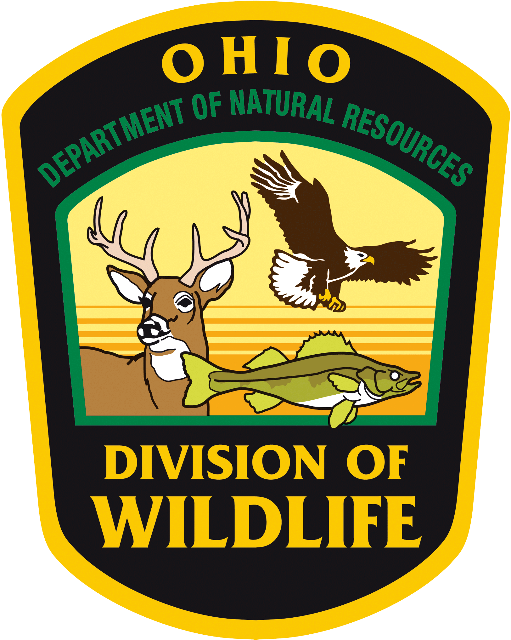
Student Wildlife Research Symposium
51st EECO Conference
April 12, 2018
10:00am to 3:30pm

9:00-9:45am Registration and Poster Set-up
10:00am Opening Remarks- ODNR-Division of Wildlife
10:15am Keynote-Greg Lipps-The Ohio Biodiversity Conservation Partnership at The Ohio State University—Of Salamanders and Snakes: Partnerships to conserve Ohio's Amphibians and Reptiles—Ohio is home to a diverse assemblage of salamanders, frogs, snakes, lizards, and turtles, many of which are rare or declining. Conservation of remaining populations and their habitat, and recovery of Ohio's "herps" requires a multitude of partners taking on a wide range of activities. These range from research to understand the ecology and threats facing populations, to developing programs to restore and manage habitat. The Eastern Hellbender - Ohio's largest salamander - and the Massasauga - a small rattlesnake - are two species that have been the focus of such partnerships in Ohio. We'll explore what these partnerships are doing, the obstacles facing the recovery of these species, and what lessons can be learned to increase success in wildlife conservation programs.
11:00am Gardezi, Hammond, Sweeny, Chao, Cvelbar, and Leone—Measures of Species Diversity on University School’s Campus in Northeast Ohio--Measures of species diversity were calculated using data from automated field cameras systematically rotated around the campus of University School’s Upper Campus. Data will be used to provide a baseline of species diversity for the campus.
11:25am Losey, Ward, Simmons—The Determination of Genetic Relatedness of Co-brumating Eastern Box Turtles—West Clermont High School--We will be discussing the relative genetic relationships of eastern box turtles found brumating in the same burrow. Topics include factors that can be used to determine the level to which these turtles are genetically related and the potential population genetics and social impacts of this observed behavior.
11:50am Introduce Poster Presenters
12:00pm Lunch-- Meet a Biologist! Meet and greet with ODNR and other resource agency staff
1:15pm Poster Session-Review Posters and discussions with students
2:00pm Heger and Boggess—The Movement of Eastern Box Turtles over Three Successive 24-hour Time Periods—West Clermont High School--GPS data loggers were attached to three turtles and their hourly locations recorded for three consecutive 24-hour periods. Periods of movement were compared to time of day and ambient weather conditions. Trends were noted and possible causative factors were investigated.
2:25pm Jordan Skates—Survey of Three Different Wetlands and their Ability to Remove Excess Pollutants—Pettisville High School--Three wetlands were compared to determine how age of wetland affects the ability of the wetland to remove access farm nutrients. The hypothesis was Pettisville School wetland (5 years) would filter out more ppm of the pollutant than the Nofziger’s wetland (20 years) and Goll Woods Nature Preserve (300 years).
2:50pm Break-visit exhibitors
3:00pm Award Presentation—Formal Educator of the Year from EECO
3:15 pm Closing Remarks-Jen Dennison, Wildlife Education Coordinator, ODNR-Division of Wildlife
3:30 pm Safe Travels!
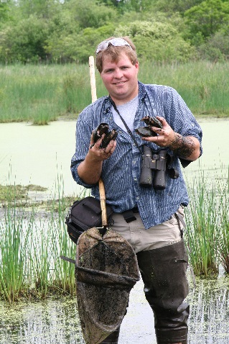
Greg Lipps is the Amphibian & Reptile Conservation Coordinator for the Ohio Biodiversity Conservation Partnership at The Ohio State University. Born in Cincinnati, Ohio, Greg moved to Toledo in 1995 to take a position in the Department of Herpetology at the Toledo Zoo. After leaving the zoo, he completed his Masters in Biology in 2005 at Bowling Green State University, focusing on utilizing emerging technologies (Geographic Information Systems and Remote Sensing) for applied conservation. After graduating, Greg worked as an independent biologist for state agencies and NGO’s, conducting surveys of amphibians and reptiles throughout the state and collaborating on conservation strategies for a wide range of species and ecosystems. For the past decade, Greg has spent much of his time investigating the status and distribution of Eastern Hellbenders and Massasaugas, determining threats to the viability of populations, and leading a partnership to restore populations in Ohio. Greg is an editor and contributing author to the recently released book Amphibians of Ohio and the forthcoming Reptiles of Ohio. He resides in the Oak Openings Region southwest of Toledo and is the founder and Co-Chair of the Ohio Chapter of Partners in Amphibian and Reptile Conservation (PARC) and previous Co-Chair of Midwest PARC.

