Need College Credit, CEU’s or just want to have some fun?

Try…EECO Tours - October Tour

An Urban Watershed Leisurely Bicycle Ride: Cuyahoga River & Doan Brook
BYOBicycle! If you do not have a bike or are unable to bike you can still attend this tour.
photo: Urban Ag

What we will do:
- Travel upstream from the mouth of Doan Brook and explore its hidden sewershed.
- Discover stormwater features along the historical Cleveland Cultural gardens.
- Interpretive stop at the Cleveland Public Square Green Infrastructure site.
- Take a virtual wastewater tour and discover the legacy of combined sewers in the region.
- Water Chemistry Testing: Cuyahoga vs Doan vs Lake Erie.

When: Sunday, October 21st

Cost: $25.00

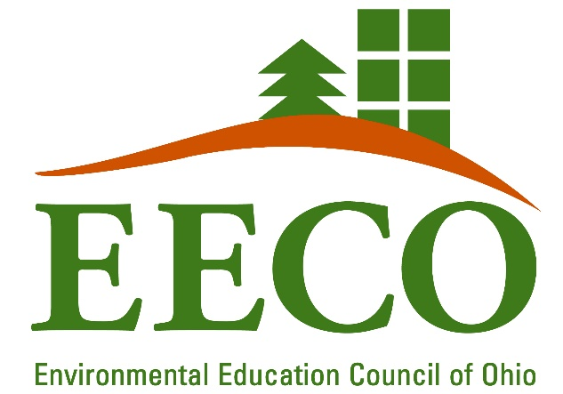
Schedule:
9:00a Meet at Edgewater Beach House (6500 Cleveland Memorial Shoreway, Cleveland, OH 44102
for meet & greet, *continental breakfast
~18 miles round-trip
12:00p Lunch (bring your own brown bag) @Edgewater Beach House
12:30p Virtual wastewater tour & Water Chemistry
1:00p Fabulous Fall Farewell!

Register online at www.eeco-online.org you can get more information by contacting:
Ebony Hood @SYATT
syattcle@gmail.com or call/text
216-346-5887

(To be eligible for college credit you will need to attend at least 3 EECO Tours. We will be offering 4 tours, one per season.)

